Design Document - HOUSEMAX

1. System Architecture

The HOUSEMAX platform follows a modern, serverless architecture leveraging React for the frontend and Supabase for backend services.
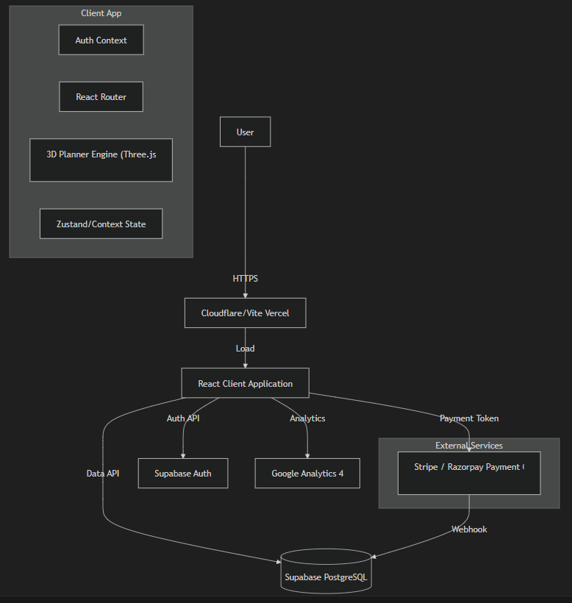
2. Database Schema

The database is built on PostgreSQL (via Supabase). Below is the core schema design.
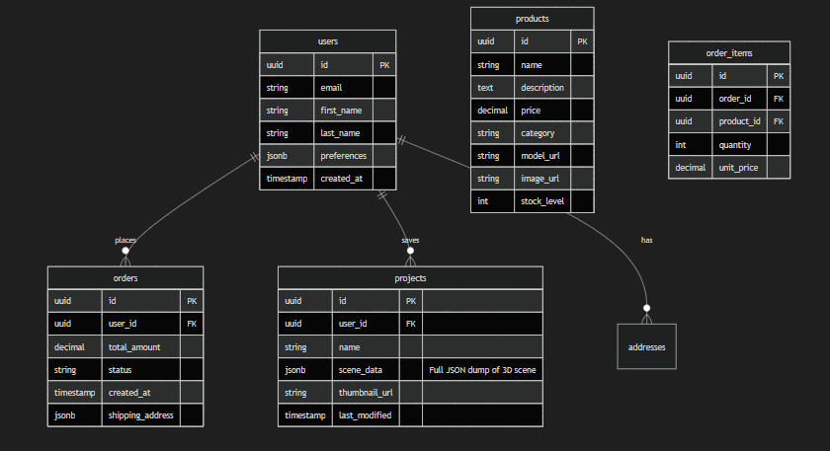
3. Wireframes & UI Design

3.1. Homepage
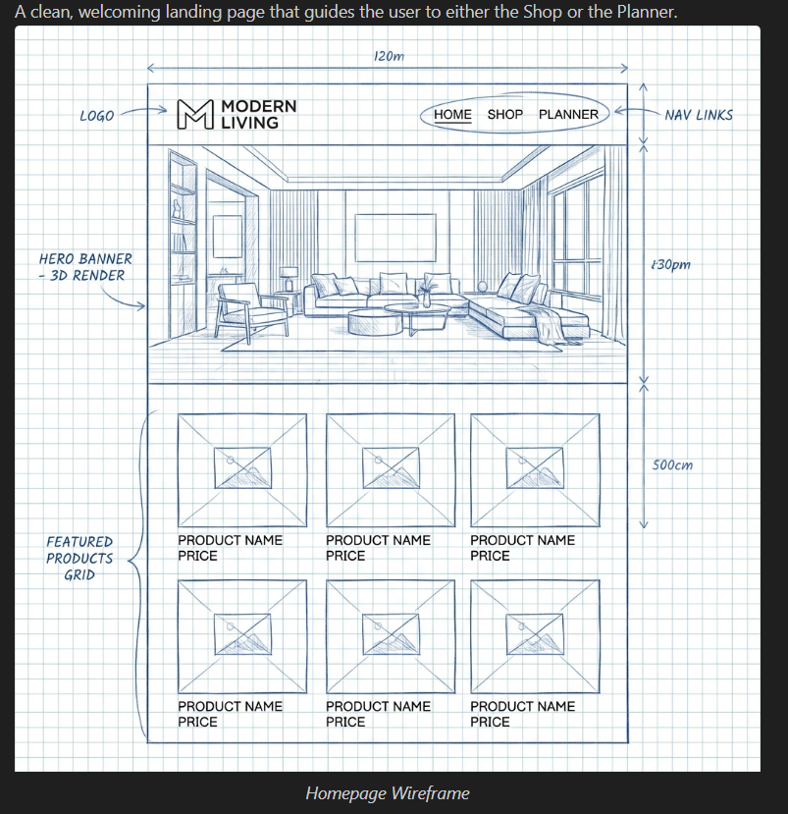
3.2. 3D Room Planner
The core feature interface. Designed to maximize the workspace while keeping tools accessible.
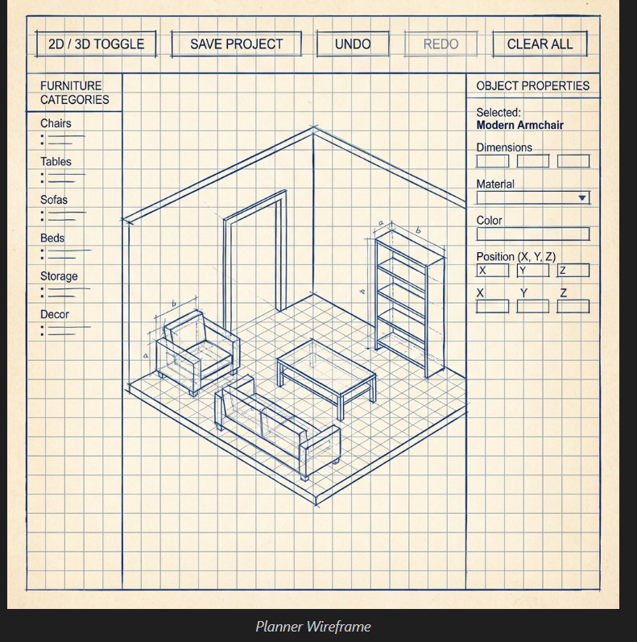
3.3. Shop & Product Listing
Standard e-commerce layout with robust filtering to help users find furniture.
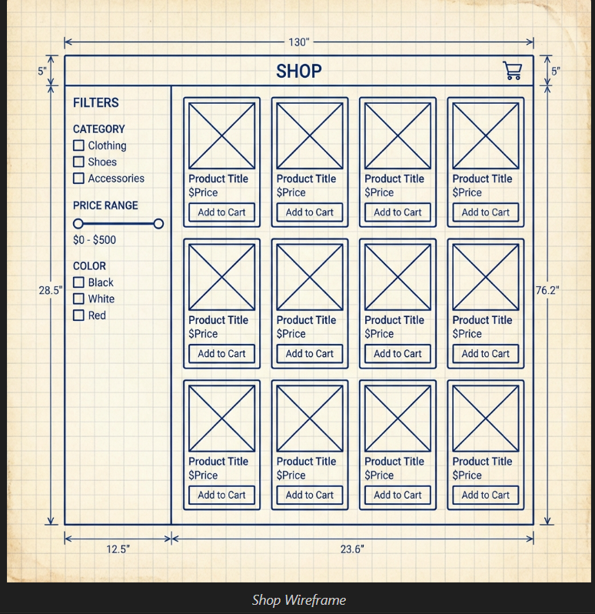
4. User Flows

4.1. Checkout Flow
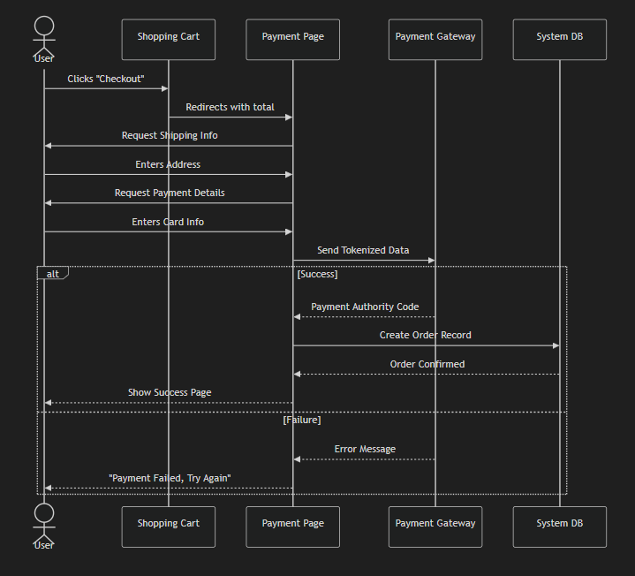
4.2. 3D Planning Flow
